# 

Developer Guidelines

How To – Integrate Connect Authentication in ASP.NET Core Applications

Table of Contents

Overview 3

Prerequisites 3

Integrating Connect Authentication 5

# Overview

LogixHealth Enterprise Extension Library is a reusable component, which are programming libraries developed using .NET Core (version 2.1) Framework. This component provides an interface for integrating Connect Authentication from an application (Consumer) that reduces the huge amount of code/configurations that are required. They are designed to help developers to

* Initialize Asp.Net Core Contexts
* Integrate LH Connect Authentication
* Integrate LH Connect Header and Footer

# Prerequisites

* This component developed using .NET Core 2.1 (can be consumed by applications developed using .NET Core 2.1 and above)
* Go to TFS <http://bedtfsapp001:8080/tfs/main> > EnterpriseLibraries > StableVersion
  + Map this TFS folder $/EnterpriseLibraries/StableVersion to [C: or D: drive]:\TFS\EnterpriseLibraries\StableVersion and Get the latest code base
* Go to your application folder and open your application solution file in Visual Studio 2017
  + Right click on Solution file > click Add > click New Solution Folder > name this folder as “Dependencies”
  + Right click on this Solution Folder “Dependencies” and add the following projects from the location where you have mapped

|  |  |
| --- | --- |
| Order | For .NET Core Application |
| 1 | LogixHealth.EnterpriseLibrary.AppServices.Gateway.Core |
| 2 | LogixHealth.EnterpriseLibrar.Extensions.Core |

* + Rebuild/Build these projects and make sure there`s is no reference related errors
* Go to your IIS, configure the attached “Connect Authentication / Connect Portal Services / Connect Extension Services” to your local IIS (This contains only the deployment libraries, no need to download the LogixHealth Connect Applications locally to configure the same) and make sure it`s working

|  |  |  |
| --- | --- | --- |
| Order | File Name |  |
| 1 | ConnectPortalServices.zip |  |
| 2 | ConnectAuthentication.zip |  |
| 3 | ConnectExtensionServices.zip |  |

* + Go to “C:\inetpub\wwwroot” > extract the above attached zip files in to this folder.
  + Go to IIS > Default Web Site > right click Refresh
  + You can find the folders (ConnectAuthentication, ConnectPortalServices, and ConnectExtensionServices)
  + Right click on each folder > click “Convert to Application”
  + Go to your IIS, right click on the Application Pool “Default Web Site” > click Advance Settings > select Process Model > Identity > Application Pool Identity > Custom Account > Set > enter your LH Corp Credentials and Click OK

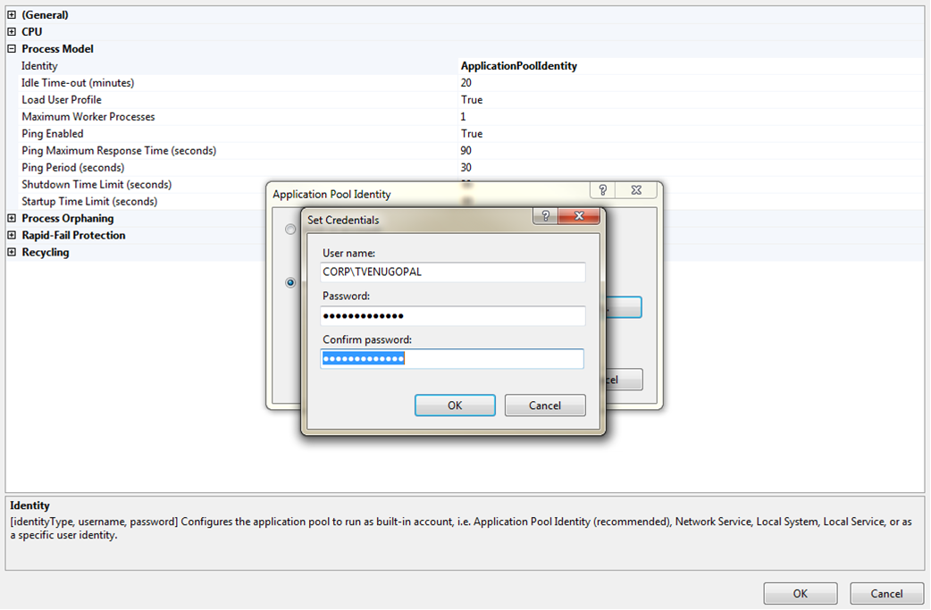

* + Right click the web site “Default Web Site” > Advance Settings > Behavior section > Enable Protocols > add these entries “http,https” > click OK
  + Right click the web site “Default Web Site” > Edit Bindings > click Add > select https from the “Type:” dropdown > select “localhost” certificate from “SSL Certificate:” dropdown > click OK

# Integrating Connect Authentication

* After downloading the Enterprise Libraries and your projects, make sure all the projects are mapped to root folder (as per the TFS Folder structure) as shown below

Example –

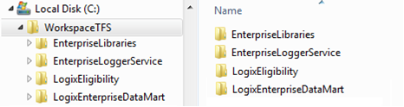

* Go to your .NET Core Application, reference the above mentioned projects as Project Reference
* Go to your .NET Core Application Setting JSON file and add these configuration keys

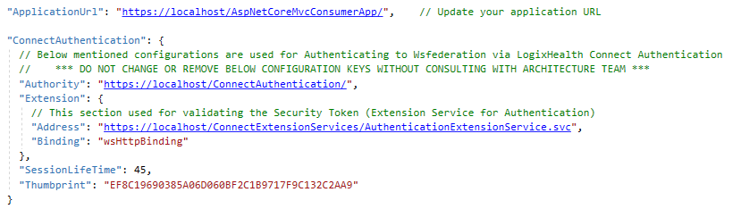

* Go to your .NET Core Application, open STARTUP.CS file
  + Remove unused USINGs
  + Add the following namespaces



* + Go to ConfigureServices method and add the following code as shown below

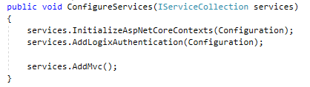

* + Go to Configure method and add the following code as shown below

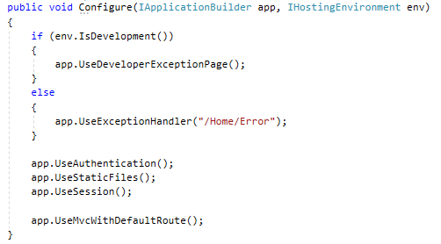

* Go to your Controller classes and remove the default base controller class instead derive it from LogixController base class as shown below



* Rebuild your solution and run the application. This will redirect to Connect Authentication and once it authenticated will return to your application.